**SQL ASSIGNMENT 1**

The database and table structure of the given data set:

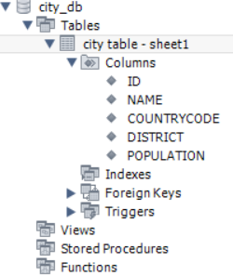

**QUESTION 1**

Query all columns for all American cities in the CITY table with populations larger than 100000.

The Country Code for America is USA.

**ANSWER 1**

SELECT * FROM city_db.`city table - sheet1`where COUNTRYCODE='USA' and POPULATION > 100000;

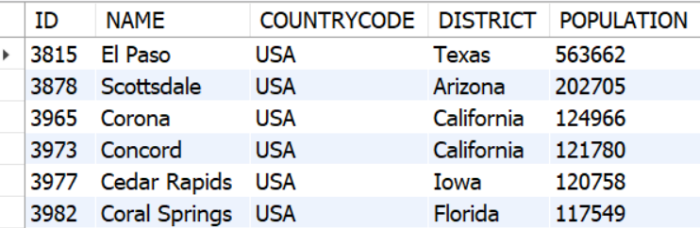

**QUESTION 2**.

Query the NAME field for all American cities in the CITY table with populations larger than 120000.

The Country Code for America is USA.

**ANSWER 2**

SELECT NAME FROM city_db.`city table - sheet1`where COUNTRYCODE='USA' and POPULATION > 120000;

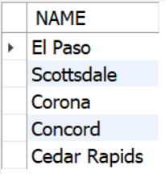

**QUESTION 3**

Query all columns (attributes) for every row in the CITY table.

**ANSWER 3**

SELECT * FROM city_db.`city table - sheet1` LIMIT 5;

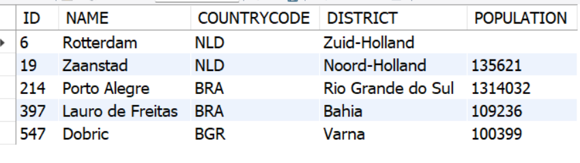

**QUESTION 4**

Query all columns for a city in CITY with the ID 1661

**ANSWER 4**

SELECT * FROM city_db.`city table - sheet1` WHERE ID=1661;

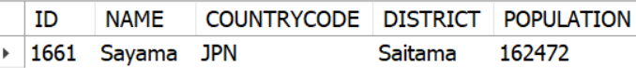

**QUESTION 5**

Query all attributes of every Japanese city in the CITY table. The COUNTRYCODE for Japan is JPN.

**ANSWER 5**

SELECT * FROM city_db.`city table - sheet1` WHERE COUNTRYCODE='JPN';

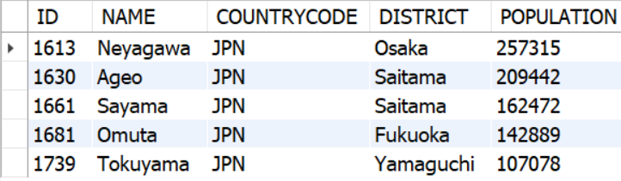

**QUESTION 6**

Query the names of all the Japanese cities in the CITY table. The COUNTRYCODE for Japan is JPN.

**ANSWER 6**

SELECT NAME FROM city_db.`city table - sheet1` WHERE COUNTRYCODE='JPN';

